Dear Parent/Guardian,

Your student will soon participate in a Chesapeake Bay Foundation (CBF) Student Field Program. CBF is a private, non-profit conservation organization dedicated to saving the Chesapeake Bay. Along with other restoration and advocacy efforts, CBF introduces participants to the wonders of the watershed and works to heighten sensitivity, increase knowledge, and empower community members to take positive action toward the Bay's restoration.

For over five decades, CBF has led 1.5 million participants in hands-on, outdoor learning opportunities. Whether on a one-day canoe or boat experience or a weeklong stay at a residential island education center, our teaching philosophy is the same – To care for the environment, you must love it. To love it, you must know it. And to know it, you must experience it.

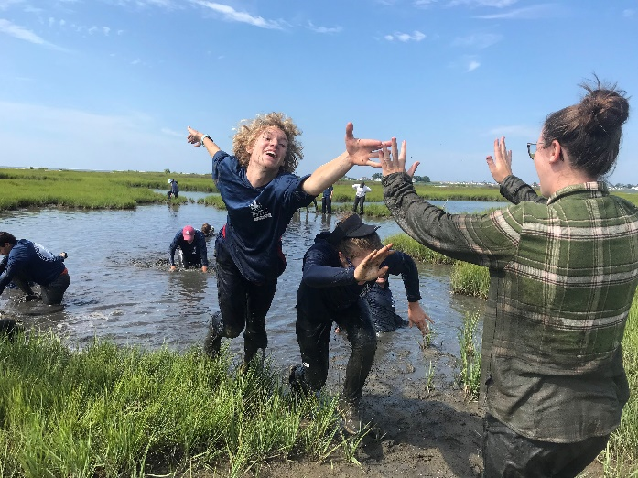 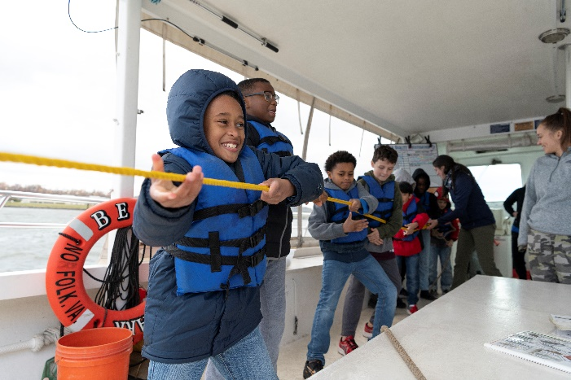

Kassie Fenn

Jay Fleming

During the education program, your student will participate in a variety of outdoor activities – like pulling a trawl net for fish, marsh mucking, canoeing, and/or dredging for oysters – they may get WET and MUDDY. Preparing your student for this experience will make their outdoor learning both fun and rewarding.

Please prepare your student for their CBF Student Field Program by completing the following:

* Read the Participant Information below. Learn what to wear, what to bring, and understand the expected behavior on a CBF Student Field Program.
* Complete both pages of the [CBF Field Program Health Form](https://www.cbf.org/document-library/education-field-experience-registration-forms/health-form-combined-2025.pdf) and provide it to the teacher/group leader.

To learn more about CBF education programs, visit [www.cbf.org/education](http://www.cbf.org/education).

Sincerely,

Chesapeake Bay Foundation

Education Program Manager

CBF STUDENT FIELD PROGRAM  
**PARTICIPANT INFORMATION – MULTI DAY PROGRAMS**

**WHAT TO WEAR & WHAT TO PACK**

Appropriate clothing and gear for weather conditions is essential for a safe and successful learning experience. Most activities will take place outside on or near the water. Check the weather forecast as the program date nears.

☀️ Warm Weather: In warm weather, staying hydrated and protecting yourself from the sun are key!

❄️Cold Weather: It can feel 10-15 degrees (°F) cooler on the water. Clothing layers are important.

**PACKING LIST**

* Clothes for 3 days (pants, long and short sleeved shirts, sweatshirts, fleece)
* Closed-toed shoes must be worn for all programming. Recommend 2 pairs.
* One outfit for marsh mucking – long sleeve layer, long pants, tennis shoes that will all get VERY muddy and one bathing suit to wear while washing off.
* Raingear – even if it is not forecasted, pack raingear, ponchos are okay

Warm Weather

* Lightweight long pants for bug protection
* Shorts
* Lightweight top layers
* Hat, sunshirt, sunglasses, sunscreen, lip balm

Cold Weather

* Warm, hooded waterproof coat
* Warm, waterproof footwear
* Warm hat, gloves, scarf
* Long johns, base layer, and/or warm underlayers

Essential

* Sleeping bag & pillow
* Towel
* Reusable water bottle
* Plastic bag for wet clothing
* Bandana to use a napkin
* Pen/pencil & journal
* Flashlight
* Toiletries – toothbrush, toothpaste

Recommended

* T-shirt for art activity
* Flipflops or inside shoes
* Camera
* Binoculars

Muddy clothing and shoes cannot be discarded at the residential island center.

CBF STUDENT FIELD PROGRAM

**PARTICIPANT INFORMATION – MULTI-DAY PROGRAMS**

**PROGRAM POLICIES**

1. Participants are expected to conduct themselves in a manner that is safe, respectful and open for learning.
2. Participants are expected to follow all directions, rules, and policies covered in the program information and conveyed by staff.
3. Behavior deemed unsafe, inappropriate, unmanageable, or disrespectful to others can result in programing reduction or cancellation.
4. Use of cell phones for cameras or educational programming is up to the discretion of CBF staff.
5. Non-skid, closed toe shoes must be worn at all times.
6. No smoking, vaping, alcoholic beverages, or illegal drugs allowed.
7. Chesapeake Bay Foundation is not responsible for lost, damaged, or stolen valuables.

**FACILITIES POLICIES**

1. Do not walk on any other dock other than CBF’s dock unless accompanied by a chaperone. Use a buddy system when walking around the island during free time.
2. Do not ride on motorbikes or cars or golf carts.
3. House phone is for staff only. No unauthorized use. No public telephone is available.
4. No food allowed in dorm rooms.
5. All biological specimens must remain in the lab.
6. All relics of historical value will remain at the facility.
7. Do not enter any bedroom other than your own, unless instructed by staff.
8. Participants are responsible for any damage done to the facility. All damages will be reported to school authorities or the sponsoring organization for proper disciplinary action and monetary reimbursement.

**CBF staff have the right and responsibility to cancel a Student Field Program that is in progress if unsafe activity by participants warrants it.**

CBF STUDENT FIELD PROGRAM

**PARTICIPANT INFORMATION – MULTI-DAY PROGRAMS**

**TEACHER AND CHAPERONE GUIDELINES**

Thank you for joining a Chesapeake Bay Foundation (CBF) Student Field Program. You are about to embark on a truly unique experience. During the field day, please keep in mind the following guidelines:

* The success of the 3 days / 2 nights will come from a healthy collaboration between CBF staff and teachers.
* You are expected to participate fully in ALL field activities. Remember you will be spending significant time outdoors. You may get wet and muddy, so dress appropriately for the weather. See Participant Information details above regarding what to wear and what to pack.
* You are responsible for the discipline of all participants, which may include removing individuals from activities if they are not participating properly.
* You are expected to follow all Chesapeake Bay Foundation program and facilities policies, and all instructions and rules conveyed by staff.
* You will need to assist in assigning meal prep/clean up duty, organizing/planning meals, and ensuring that CBF facilities are properly cleaned. Check with CBF staff for additional information about disposing of waste, recycling, and composting at the residential island education center.
* Along with the other participants, you will be sleeping in dorm-style housing. Your assistance is required to ensure that participants maintain the facility schedule for lights out/wake up time. Check with the CBF educators for your group’s activity schedule each day.
* You are responsible for participants’ behavior throughout the evening after the educational programming is complete for the day.